Effects of ocean acidification

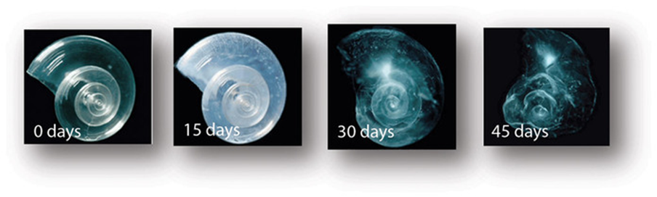

**Module Description**

This module focuses on acidity and its effect on the ocean ecosystem. Beginning with solutions, ions, and concentrations, the lesson will introduce the concept of acidity and its impact on ocean life, giving examples of the influence of acidity on chemical and biological processes taking place in the ocean, such as carbon storage and calcification. Finally, the current efforts or options under consideration aimed at mitigating these effects will be reviewed.

The ocean acidification module teaches students about the problem of ocean acidification, which is a direct consequence of a changing climate, and can be of particular interest to industrialized regions. Moreover, the module will link to a variety of current research going on at MIT, notably at the Woods Hole Oceanographic Institution. This is done not through a traditional lecture, but through hands-on learning activities that allow the students to become familiar with the concepts in a way that takes to heart MIT’s Mens et Manus motto. Further, this module ties the scientific topics it covers to relevant societal problems, such as human impact on ocean life, and helps students see the palpable impact of chemistry topics they may have otherwise thought of as intangible.

**Activity**

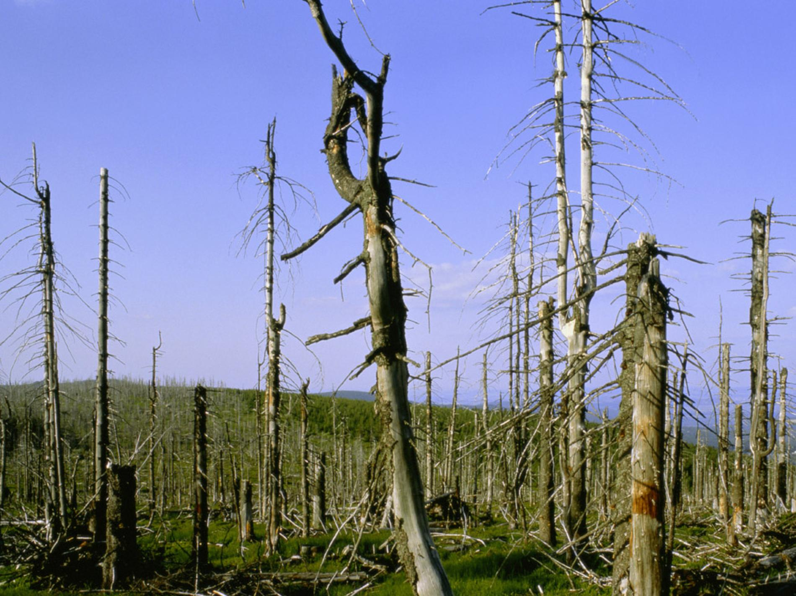

Why does acidity matter?

The activity revolves around the concept of acidity. Students are given different household chemicals and drinks (milk, seltzer water, baking soda dissolved in water, soapy water, tap water, Vitamin C tablets dissolved in water…), asked to make hypotheses as to the acidity of each solution, and then test them. Reflecting on their findings, participants will be asked to consider the consequences for both themselves and the environment when it comes to using higher amounts of some of the chemicals they tested and how they can change the pH level of water. In a parallel activity, the teacher sets up a shell-dissolution experiment for them to visually witness the effect of acidity on living organisms in the ocean. If needed, an additional activity could be to look for and explain facts about ocean acidification (such as in the [FAQ sheet put together by the Woods Holes Institute](http://www.whoi.edu/fileserver.do?id=165564&pt=2&p=150429)) to test their understanding of the physical principles at play.

Learning Goals

The learning goals revolve around students’ understanding of acidity, i.e. knowing that a lower pH means a more acidic solution while a higher pH means a more basic solution. These students will also be assessed on their understanding of the general causes of ocean acidification, such as human-generated greenhouse gases being absorbed into ocean water and making it more acidic, resulting in the dissolution of mollusk shells, the endangerment of species, and the disruption of certain food chains. They should understand that the more acidic ocean water becomes, the more these shells will dissolve.